**Return on Assets (ROA) Analytics - Manufacturing Sector**

GOKULNATH K & E24755

**Overview**

Return on Assets (ROA) Analytics in the Manufacturing Sector assesses how efficiently a company utilizes its assets to generate profit. It involves calculating the ROA ratio by dividing net income by total assets, providing insights into asset management effectiveness. Data analysts leverage this metric to identify trends, benchmark performance against industry standards, and pinpoint areas for operational improvement. By integrating ROA with other financial metrics, analysts can develop comprehensive strategies to enhance profitability and asset efficiency.

**Objective**

1. Enhance Asset Utilization: Identify and optimize underutilized assets to improve productivity and efficiency, ensuring that every asset contributes effectively to profitability.
2. Increase Profitability: Focus on strategies that boost net income, such as cost reduction measures and process improvements, to enhance overall financial performance.
3. Benchmark Performance: Compare ROA against industry standards and competitors to assess operational efficiency and identify areas for improvement.
4. Support Strategic Decision-Making: Utilize ROA data to inform investment decisions, resource allocation, and expansion strategies, ensuring alignment with long-term business goals.
5. Facilitate Continuous Improvement: Implement a framework for regularly monitoring and analyzing ROA to drive ongoing enhancements in manufacturing processes and asset management.
6. Integrate Advanced Technologies: Leverage automation and data analytics tools to streamline operations, reduce costs, and ultimately improve ROA metrics.
7. Monitor Financial Health: Use ROA as a key indicator of financial stability, helping stakeholders understand the company's ability to generate returns from its asset base.

**Assigned Task(s)**

* Return on Assets (ROA) Analytics - Manufacturing Sector.
* **Status:** Completed.
* **Details:**

1. **ROA Calculation:**

* Calculated ROA using the formula: ROA=(Net Income/Total Assets)×100

1. **Average ROA by Industry:**

* Visualized average ROA for different industries using a bar plot.

1. **Average ROA by Year:**

* Developed a bar plot showing average ROA across years (2010-2020).

1. **ROA Trends by Industry:**

* Created a line plot illustrating ROA trends over time for each industry.

1. **Heatmap of ROA:**

* Generated a heatmap to display ROA for each company across the years.

1. **Scatter Plot: Total Assets vs. ROA:**

* Produced a scatter plot showing the relationship between Total Assets and ROA, annotated with company names.

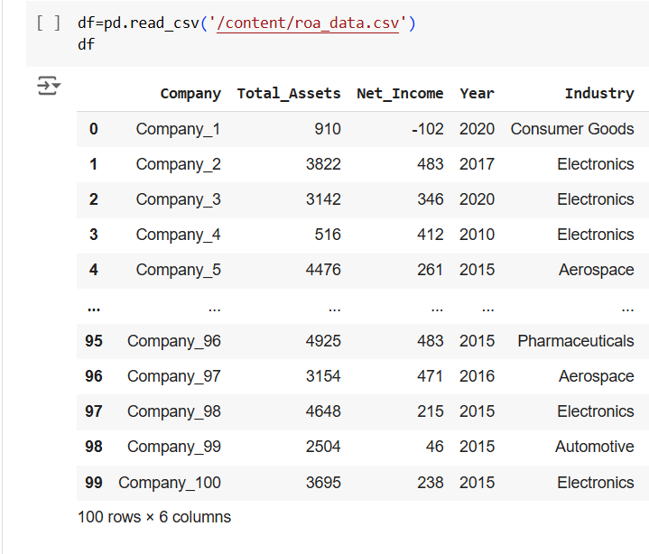

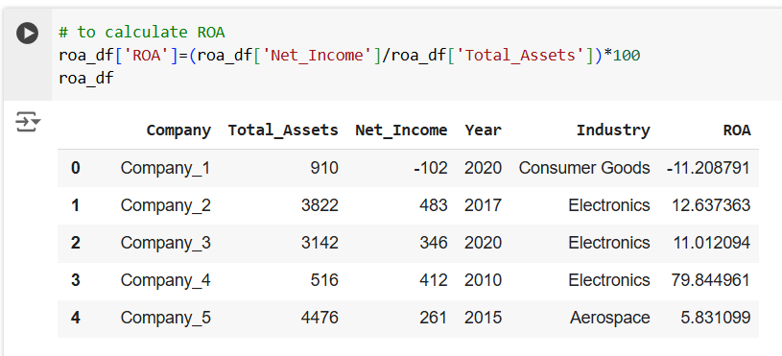

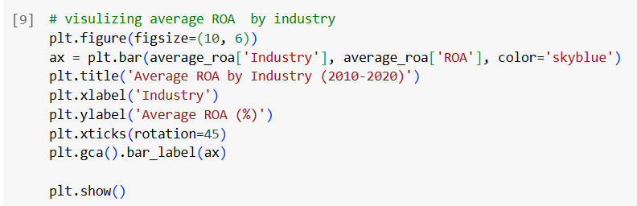

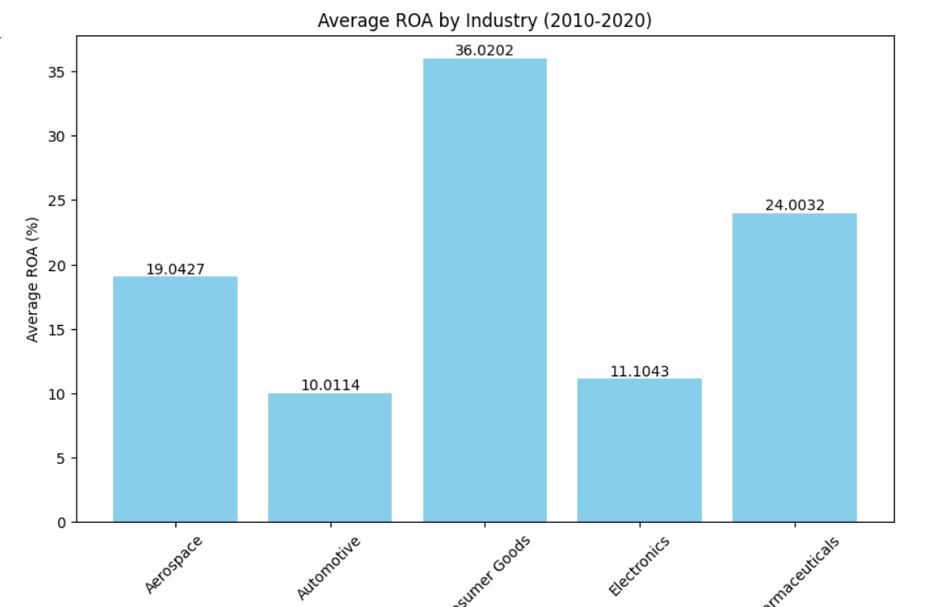

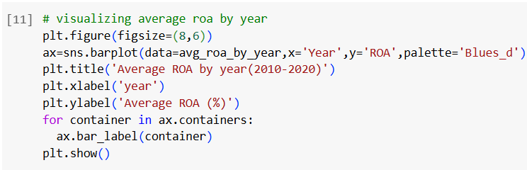

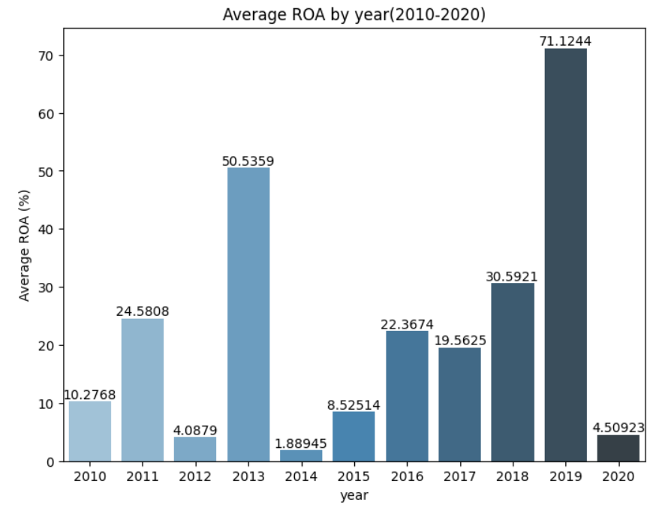

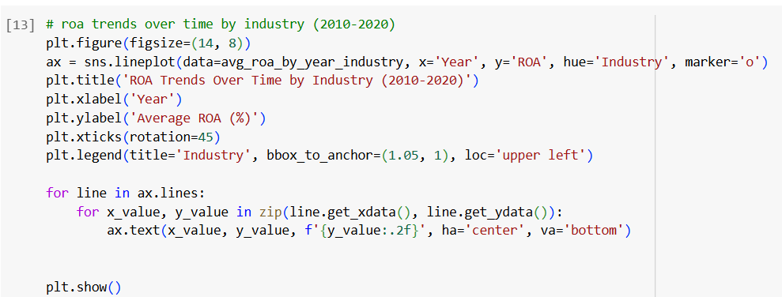

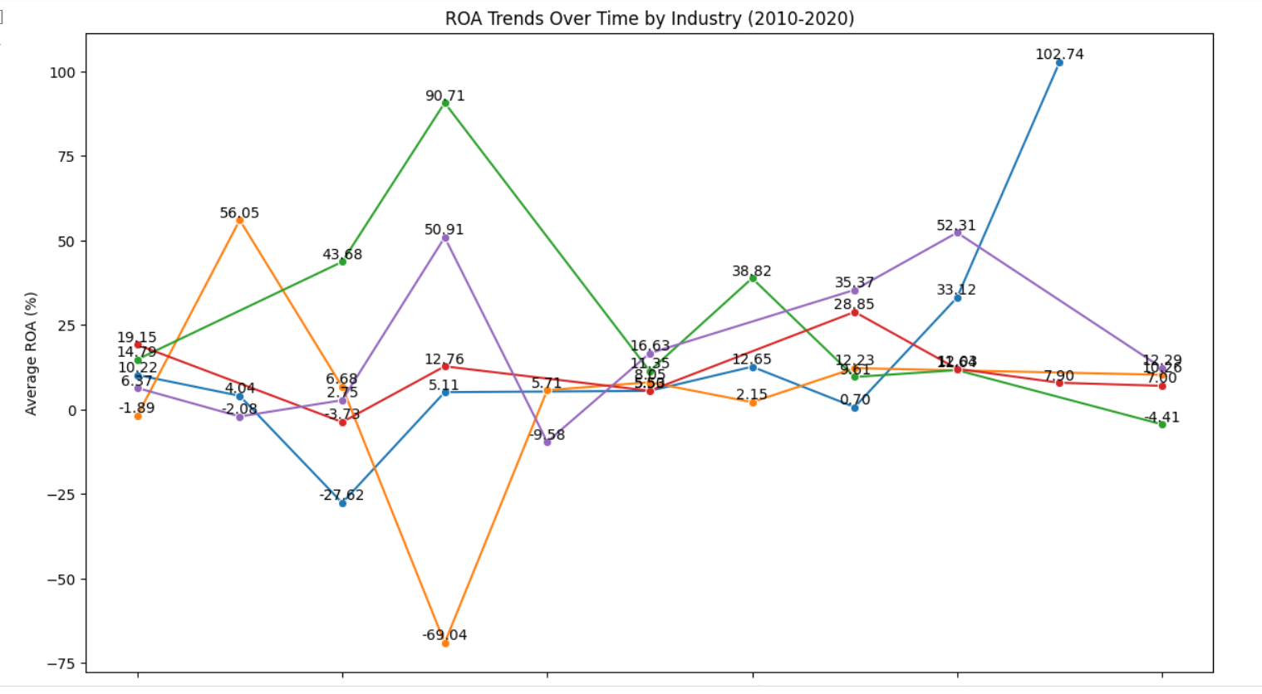

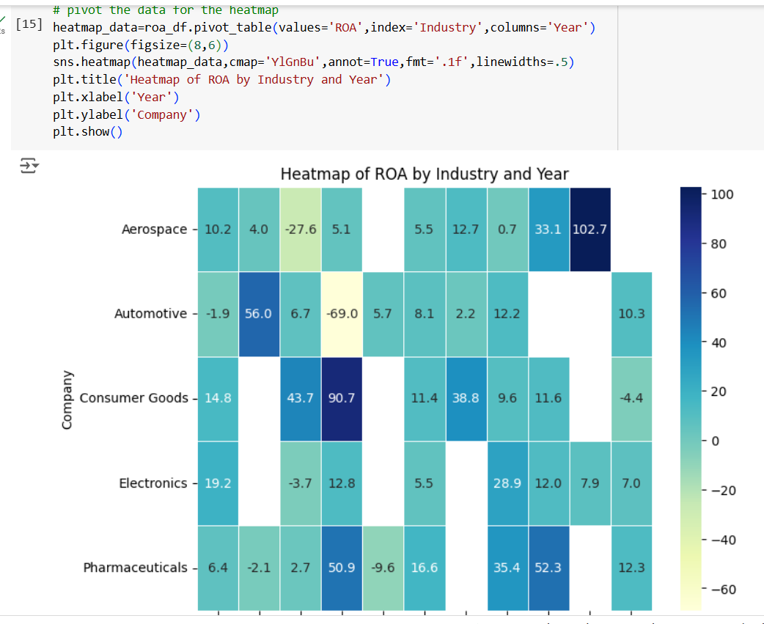

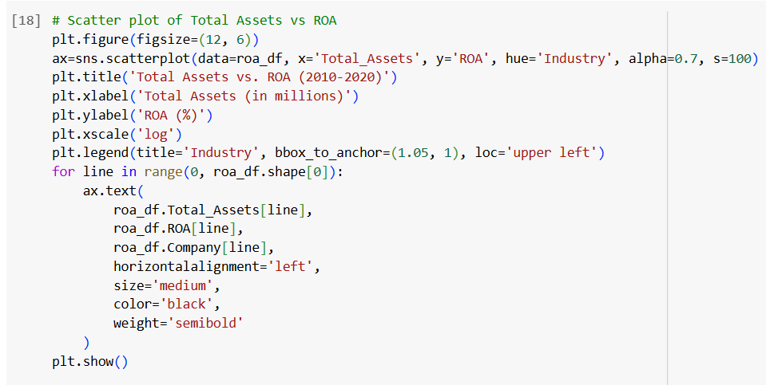

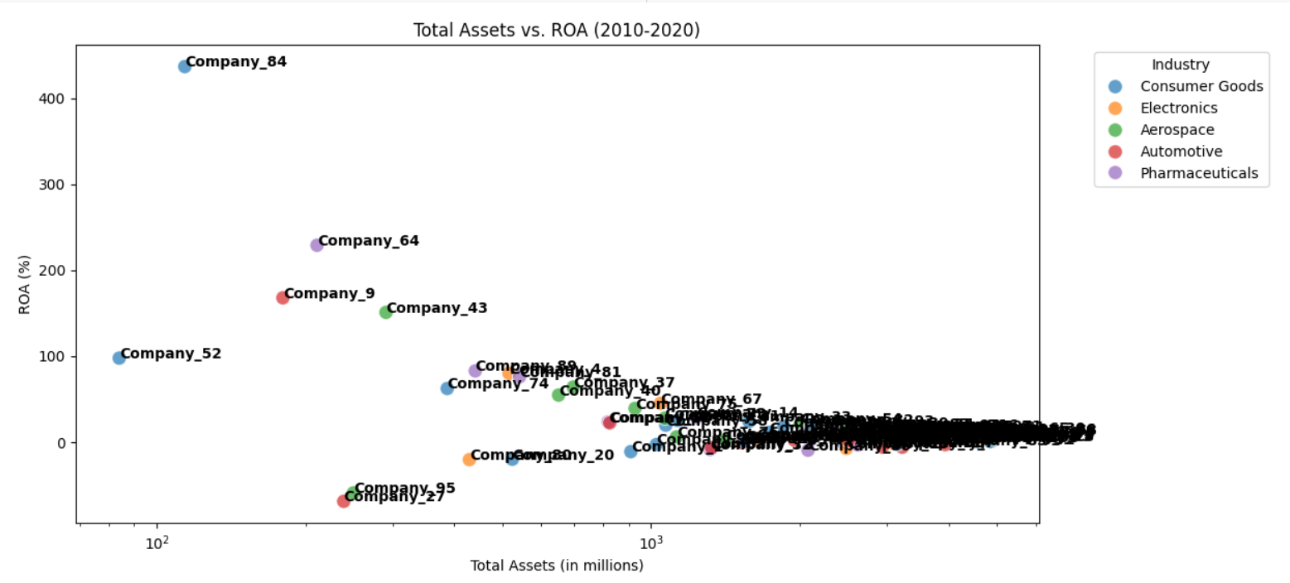

**Progress**

* **Accomplishments:**

1. Implemented the ROA formula to measure asset efficiency for companies.
2. Created a bar plot to compare average ROA across industries.
3. Developed visualizations to track average ROA over the years (2010-2020).
4. Generated line plots to illustrate ROA trends by industry.
5. Produced a heatmap to visualize ROA performance across companies.
6. Analyzed the relationship between Total Assets and ROA using a scatter plot.

* **Metrics:**

1. Calculated as a percentage, indicating how effectively a company uses its assets to generate profit.
2. Mean ROA value for each industry, providing insights into comparative performance.
3. Average ROA calculated annually from 2010 to 2020, highlighting trends over time.
4. Standard deviation of ROA by industry, indicating stability and risk associated with asset utilization.
5. Year-over-year changes in ROA percentages, identifying improvements or declines in asset efficiency.
6. Range and mean of Total Assets across companies, contextualizing the asset base relative to ROA.

**Challenges and Solutions**

* **Challenges Faced:**

1. Inconsistent or incomplete financial data can skew ROA calculations.
2. Economic fluctuations affecting ROA over time may complicate trend analysis.

* **Solutions Implemented:**

1. Implement data validation and cleaning processes to ensure accuracy.
2. Incorporate external economic indicators to contextualize ROA trends.

**Next Steps**

* **Upcoming Tasks:** Should leverage advanced analytics tools, maintain data integrity, and focus on actionable insights for continuous improvement.
* **Goals:** Enhance operational efficiency by utilizing data-driven insights to optimize processes, reduce costs, and improve decision-making.

**Conclusion**

* **Summary:** Return on Assets (ROA) analytics provides vital insights into asset efficiency within the manufacturing sector. By calculating and visualizing ROA, industries can identify performance trends and benchmarks for better decision-making. The analysis highlights areas for improvement and drives strategic initiatives to enhance profitability. Ultimately, effective ROA management fosters sustainable growth and competitive advantage in a dynamic market environment.
* **Acknowledgements:** Thank you all for your attention and engagement, I appreciate your interest in the Return on Assets (ROA) Analytics - Manufacturing Sector.